**2017 MS Comprehensive exam objectives for Anatomy:**

Stany Lobo PhD.

stany.lobo@touro.edu

**Fall Sem:**

1. What nerves are related to the humerus? What are the functional losses if these nerves are injured?
   1. **Axillary nerve** —related to the surgical neck of the humerus — if there is a fracture of the surgical neck, because axillary nerve is in close contact with it. so you have two muscles that will be paralized — the deltoid and teres minor — cant abduct the shoulder
   2. **The radial nerve** — runs in the surgical groove causes wrist drop “Saturday night palsy”— compression of the radial nerve can make the hand temporarily paralyzed — also when there is an injury to the radial nerve you lose sensation back of hand, so half of back of hand excluding, the tips of middle, index and thumb —radial never never supplies the nail beds —
   3. **Ulnar nerve:** to the medial epicondyle of the humerus: claw hand
2. Be able to identify what part of the brachial plexus is injured in Erb’s Palsy and Klumpke’s paralysis and what are their clinical features?
   1. **Erbs palsy —upper trunk** — C5- C6, sholder id adducted and elbow is extended
   2. **klumpke’s paralysis** Lower trunk, C8-T1, all the muscles of the HAND are paralyzed.

1. Which muscles are the intrinsic muscles of the hand? What are their actions? Which nerve innervates them? Actions of intrinsic muscle s of the hand is controlled by which spinal cord segments?

Thenar: for the thumb mostly done by Medial nerve accept for adductor pollicis which is done by Ulnar

Hypothenar: done by Unlar

Interossei: ulnar

Lumbricals: 12 by median and 34 by ulnar

Spinal segment C8-T1

1. What is the action of ulnar nerve on the thumb?

Adduction of the thumb

1. Be able to ID the arteries in an arteriogram of the hand.

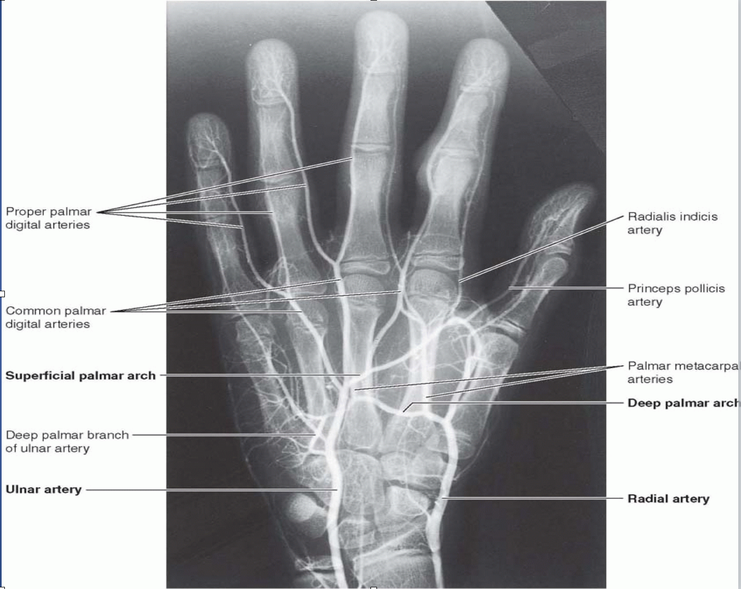

1. Flexion of the knee is done by which muscles? What is the innervation? Extension of the knee is done by which muscle? What is the innervation?
   1. Flexion: by hamstring- tibial part of sciatic
   2. Extension: quadriceps: femoral nerve
2. How would you test the integrity of the femoral nerve?
   1. Sensory input to skin of medial aspect of the leg and foot up to the ball of the big toe and the medial side of the toe
   2. Extend the leg at knee joint
3. What structures are found in the femoral triangle? How are they ordered from lateral to medial? What is the clinical importance of the femoral triangle?
   1. Femoral nerve, femoral artery, femoral vein and femoral canal, in that order from lateral to medial.
   2. Clinical importance is that femoral hernia is common in females.
4. Which muscle is attached to lesser trochanter of the femur? What is its innervation? What is its action?
   1. Iliopsoas and psoas major to the lesser trochanter - flexing the thigh at hip joint
   2. All the other muscles of the butt are for greater trochanter- extent and abduct and rotate the hip- gluteal nerves and other small nerves of the sacral plexus
5. What is the function of superior and inferior gluteal nerve? What clinical symptoms would be displayed if either nerve was damaged?
   1. Superior gluteal nerve supplies the gluteus medius and minimus which are abductors and medial rotators
   2. Interior gluteal nerve supplies the gluteus maximus which is an extensor and lateral rotator of the hip
   3. In positive trendlenberg test there is an injury to superior gluteal nerve which can be caused by trochanteric fracture, fracture of the femoral neck, dislocated hip joint. When patient stands on affected limb, pelvis on the contralateral side will sag,
6. What structures pass through the greater and lesser sciatic foramina?
   1. Greater sciatic foramen above the piriformis: = superior gluteal nerve and vessles
   2. Greater sciatic foramen below the piriformis: inferior gluteal nerve and vessles, sciatic nerve, post cutaneous nerve of thigh, pudendal nerve and internal pudendal vessles. Nerve to obturator internus.
   3. Less sciatic foramen: pudendal nerve and internal pudendal vessles. Nerve to obturator internus.
7. Adduction of hip is done by which nerve

Obturator nerve

1. How do you test the ACL and PCL tear?
   1. Do the drawer test: If the tibia can be moved anteriorly it’s the ACL tear, if the tibia can be moved posteriorly it’s the PCL tear.
2. Which chambers are enlarged in mitral insufficiency, aortic and pulmonary stenosis? Be able to ID them on a CT

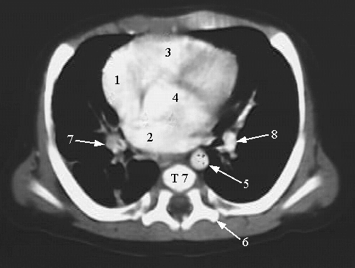

* Left ventricle is enlarged in mitral insufficiency and so is aortic stenosis
* right ventricle is enlarged in Pulmonary stenosis

1. Where is the vertebral venous plexus located? What is so different about the veins in the vertebral venous plexus? What is their clinical relevance?
   1. Vertebral venous plexus is located in the vertebral canal. Also called batsons veins.
   2. Clinical importance is that cancer from lung, abdomen and pelvis can spread to brain and skull through vertebral venous plexus
2. An aneurysm of the arch of aorta can compress which structures?
   1. The left recurrent laryngeal nerve is compressed
3. Inhaled foreign particles are usually lodged in which lung? Why?
   1. Inhaled particles enter the right bronchus. I tis in line with the traches

1. What is the ideal site for thoracentesis? Why?
   1. Done in the 7th, 8th, and 9th intercoastal space in the midaxillary line to prevent damage of lungs, liver, spleen and diaphragm
2. Know the arteries of the heart and what area each supplies.

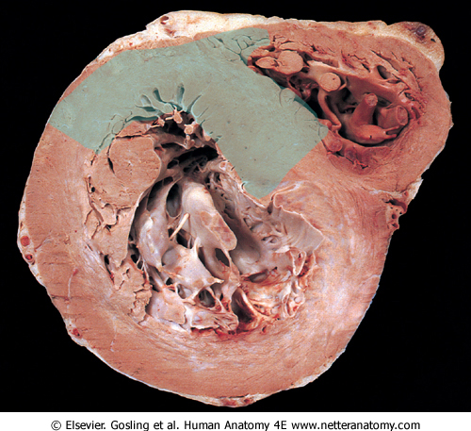

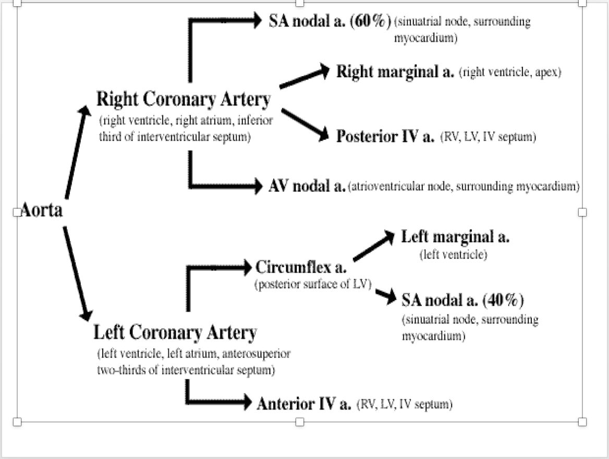

1. How can you differentiate between a direct and indirect hernia? What landmarks can you use?
   1. **Indirect hernia** goes thru the deep inguinal ring and comes out of the superficial inguinal ring. Lateral to inferior epigastric vessels
   2. **Direct hernia** pierces thru the peritoneum and comes out of the superficial inguinal ring. Medial to Inferior epigastric vessels
2. What are the different sites of portocaval anastomoses? What are clinical correlates related to portal hypertension? What two types of veins are used to surgical fix portal hypertension?
   1. **Portocaval anastomoses:** Lower end of esophagus, where tributaries of the left gastric anastomose with the trib of the azygos veins, this can lead to hematemesis
   2. Anal canal, where superior rectal with the middle inferior rectal, this can lead to hemorrhoids
   3. **Umbilicus**: Lt. branches makes commuincations thru para umbilical veins to veins of anterior abd wall. This can lead to caput medusa
   4. In portal hypertension, SVC obstruction or IVC obstruction the veins dilate. You get caput medusa
   5. **Fix it:** Connect left renal vein to splenic vein
3. Be able to identify the ligaments in the abdomen associated with individual organs, as well as what structures they all transmit.
   1. Peritoneal Ligaments
      1. Falciform Ligament- Sickel shaped peritoneal fold that connects the liver to the diaphragm, contains the ligamentum teres and periumbilical vein
      2. Ligamentum teres Hepatis – –Lies in free margin of falciform lig. and ascends from umbilicus to inferior surface of liver
      3. Coronary Ligament – Diaphgramatic surface of liver to the diaphgram
      4. Right and left triangular ligament
      5. Ligamentum Venosum – Remnant of Ductous Venousus, and lies indfissure or inferior of liver
      6. Splenorenal: has tail of the pancreas and spelenci cvessesls
   2. Stomach – The greater Curvature 🡪 Gastro-phrenic Ligament, and greater omentum 🡪 Gastrophrenic ligament, Gastrosplenic ligament.
4. Where is the lesser omentum located? Which structures does it contain?
   1. The lesser omentum is located between the lesser curvature and the 1st inch of 1st part of duodenum
   2. Content of Lesser Omentum 🡪 Hepatic artery, Portal Vein, Bile Duct, Lymphatic and Nerve Plexus
5. What structures form stomach bed? Which vessel would be first affected by an ulcer on the posterior wall of the stomach?
   1. Structures to form stomach bed 🡪 Diaphrgam, spleen, left suprarenal, left kidney, splenic vessels, pancreas, lesser sac
6. What structures are found in the median, medial and lateral umbilical folds?
   1. Median Umbilical Fold – Urachus
   2. Medial Umbilical Fold – Obliterated Umbilical Artery
   3. Lateral Umbilical Fold – Inferior Epigastric Vessels
7. What is a pudendal nerve block? The pudendal nerve is a branch of which plexus? What boney landmarks can be used as guidance during a pudendal nerve block?
   1. A pudendenal nerve block is used to block the somatic pudendal nerve which supplies the urethral sphincter, and sensation to the external genitals, the urethra, the anus, and perineum.
   2. The Pudendal Nerve is a branch of sacral plexus
   3. Ischial spine is the boney land mark

What is the rectouterine space? What is its clinical importance?

* 1. Rectouterine pouch is a pouch between the rectum posteriorly and uterus anteriorly
  2. It is the most dependent part of the abdominal cavity **when standing**  🡪 accumulation of excess fluid in the peritoneal cavity – Ascitis. Can be treated with Paracentesis abdominis.
  3. Can be reached through the posterior fornix of vagina

1. What are the branches of the internal iliac artery and what will they supply?
   1. Internal iliac artery rises from the bifurcation of common iliac artery 🡪 and becomes an Ant/Post division

**I:**[iliolumbar artery](https://radiopaedia.org/articles/iliolumbar-artery)

**L:**[lateral sacral artery](https://radiopaedia.org/articles/lateral-sacral-artery)

**G:**gluteal ([superior](https://radiopaedia.org/articles/superior-gluteal-artery-1) and [inferior](https://radiopaedia.org/articles/inferior-gluteal-artery)) arteries

**P:**(internal) [pudendal artery](https://radiopaedia.org/articles/internal-pudendal-artery-1)

**I:**[inferior vesical](https://radiopaedia.org/articles/inferior-vesical-artery) ([uterine](https://radiopaedia.org/articles/uterine-artery) in females) artery 🡪 supplies seminal vesicles, Urethra

**M:**[middle rectal artery](https://radiopaedia.org/articles/middle-rectal-artery) 🡪 Supplies the seminal vesicle, Urethra

**V:**[vaginal artery](https://radiopaedia.org/articles/vaginal-artery)

**O:**[obturator artery](https://radiopaedia.org/articles/obturator-artery):

**U:**[umbilical artery](https://radiopaedia.org/articles/umbilical-artery-1)

**They supply everything in the pelvis except of ovary or testis**

1. What is the blood supply and lymphatic drainage of the gonads?

Lymph: Para-aortic nodes. Artery: from the abdominal aorta, Veins: Left side to left renal. Right side to IVC

1. What are the contents of the superficial and deep perineal pouches?
   1. **Superficial Pouch**
      1. **Males**: root of penis, ishiocavernous and bulbospongiosus muscle, proximal part of the bulbous urethral, and ducts of bulbourethral glands, superficial transverse perineal muscle, deep perineal muscle
      2. **Females**: Clitoris and ischiocavernous muscle, bulb of vestibule, bulbospongiosus muscle, greater vestibular glands, superficial transverse perineal muscle, deep perineal branches of pudendal vessels and pudendal nerve
   2. **Deep Perineal Pouch** 🡪 Sphinter Urethrae and deep tranverse perineal muscle, membranous urethra, **bulbourethral glands (males),**  branches of internal pudendal vessels and pudendal nerve
2. What are the contents of the superficial and deep perineal pouches?
   1. **Deep perineal pouch:** 
      1. Sphinctor urethrae and deep transverse perineal muscle
      2. Membranous urethra
      3. Bulbourethral glands in male
      4. Branches of internal pudendal vessels and pudendal nerve
   2. **Superficial Perineal pouch in Males:**
      1. Root of penis, ischiocavernosus & bulbospongiosus muscle
      2. Proximal part of bulbous urethral and ducts of bulbourethral glands
      3. Superficial transverse perineal muscle
      4. Deep perineal branches of internal pudendal vessels and pudendal nerve
   3. **Superficial Perineal pouch in Females:**
      1. Clitoris & ischiocavernosus m.
      2. Bulb of vestibule, bulbospongiosus muscle
      3. Greater vestibular glands
      4. Superficial transverse perineal muscle
      5. Deep perineal branches of internal pudendal vessels and pudendal n.
3. What is a urachal fistula? How does it present? How is it different from a urachal cyst? How is it different from a urachal sinus?
   1. Allantois allows the emptying of the bladder in utero. After birth, allantois becomes a ligament, the urachus. If the allantois does not fuse properly however after birth you can end up with urachal cyst, urachal sinus and urachal fistula.

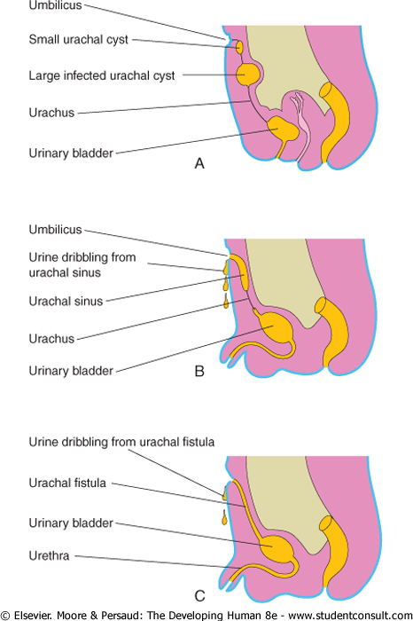

1. urachal cyst presents as an extraperitoneal mass in the umbilical region.
2. **urachal sinus** would clinically present as purulent umbilical discharge, abdominal pain, and periumbilical mass.
3. Nomally when urachus closes it becomes thee median umbilical ligament, but if it remains open urine can drain into the umbilical.
4. Urine leaks through umbilicus in fistula
5. Know the development of male and female external genitalia and be able to identify homologous structures.

|  |  |  |
| --- | --- | --- |
| **Adult Female** | **Indifferent Embryo** | **Adult Male** |
| Ovary, ovarian follicles, rete ovarii | Gonads | Testes, seminiferous tubules, tubuli recti,rete testis, Leydig cells, Sertoli cells |
| Uterine tubes, uterus, cervix, superior third of vagina | Paramesonephric duct | Appendix testis |
| Gartner’s duct | Mesonephric duct | Epididymis, ductus deferens, seminalvesicle, ejaculatory duct  Appendix epididymis |
| Epoöphoron, paroöphorona | Mesonephric tubules | Efferent ductules  Paradidymis |
| Glans clitoris, corpora cavernosa , clitoris, vestibular bulbs | Genital tubercle (Phallus) | Glans penis, corpora cavernosa penis, corpus spongiosum |
| Labia minora | Urethral folds (Urogenital folds) | Ventral aspect of penis |
| Labia majora, mons pubis, | Genital swelling (Labioscrotal swellings) | Scrotum |
| Ovarian ligament, round ligament of uterus | Gubernaculum | Gubernaculum testes |
|  | Processus vaginalis | Tunica vaginalisa |

1. What is the ideal site of implantation for a conceptus? What is the most commonly seen abnormal implantation site?
   1. The ideal site of implantation for conceptus is the fundus/ body of the endometrium. If implantation occurs in the uterus but lower part of the uterus, it is called placenta previa. Implantation can also occur in the tube or called tubal, which is the most common and this is an ectopic pregnancy.
2. What is the primitive streak? Which layers does it give rise to?
   1. Primitive streak is formed when ectoderm. So what is the point of the groove and the pit —
   2. one significance of this is the formation is that it mark the transition of the 2 layer embryonic disk that we had to moving a three layer embryonic disk which will eventually form the germ layers that will form all the structures of the body — the primitive streak says, its go time — The other significance to the formation of the primitive steak is that we now have a sense of basic plan and axis — we have a caudal end, and a cranial end — we also have a right and left — we also have dorsal and ventral, the dorsal being the epiblast layer and they ventral being the hypoblast underneath - so body axis developing
3. What is polyhydramnios? What is oligohydramnios? Improper development of which organs can lead to oligohydramnios?
   1. Polyhydramnios is high volume of amniotic fluid-
   2. Oligohydramnios is low volume of amniotic fluid- Improper development Kidney
4. What are the parts of a somite? What does each part give rise to?
   1. Paraxial plate mesoderm gives rise to somites. Somites give rise to myotome (muscle) , sclerotome ( cartilage and bone) and dermatome (skinand dermis)

**Spring Semester:**

1. What is the motor and sensory innervation of the tongue?
   1. Motor – Hypoglossal Nerve
   2. General sensory to Anterior 2/3rd is Lingual Branch of Mandibular(CNV)  
      General sensory and taste from post 1/3rd is Glossopharyngeal nerve and vagus
   3. Taste: anterior 2/3 Chorda tympani, post 1/3rd is Glossopharyngeal nerve and vagus
2. What nerves are associated with the gag reflex? Which is the motor branch? Which is the sensory branch? What are the clinical symptoms if either of the nerves are damaged?
   1. Gag reflex afferent = Glossopharyngeal and Efferent = Vagus
   2. The reflex is elicited by stroking of the posterior pharynx with a cotton-tipped swab.
3. Identify the opening of lateral wall of the nose in a image

The Meatuses   
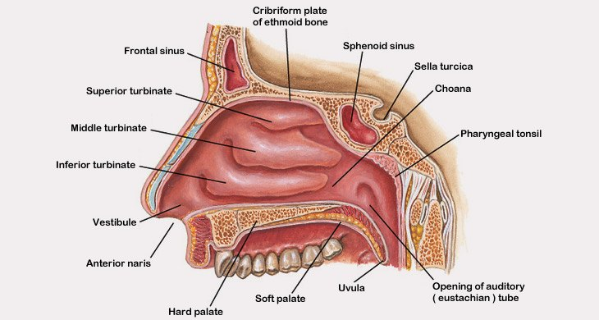

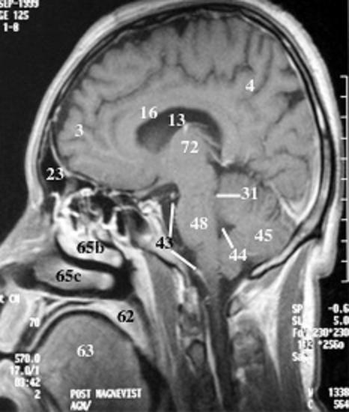

1. What are the clinical symptoms of trochlear nerve palsy? How is this different from oculomotor nerve palsy or abducens nerve palsy?
   1. Trochlear Nerve Palsy – Supreior oblique is paralyzed on one side 🡪 diplopia when looking down ( going down the stair), tilted head
   2. Oculomotor Nerve Palsy – Drooping and Ptosis – Levator Palperbrae Superiors, down and out eye ball
   3. Abducens Nerve – Lesion to abdunces = Paralysis of Lateral Rectus causing Medial Strabismus ( eyeball looking medially)
2. Given a venogram, an MRI, or a picture be able to identify the dural venous sinuses.

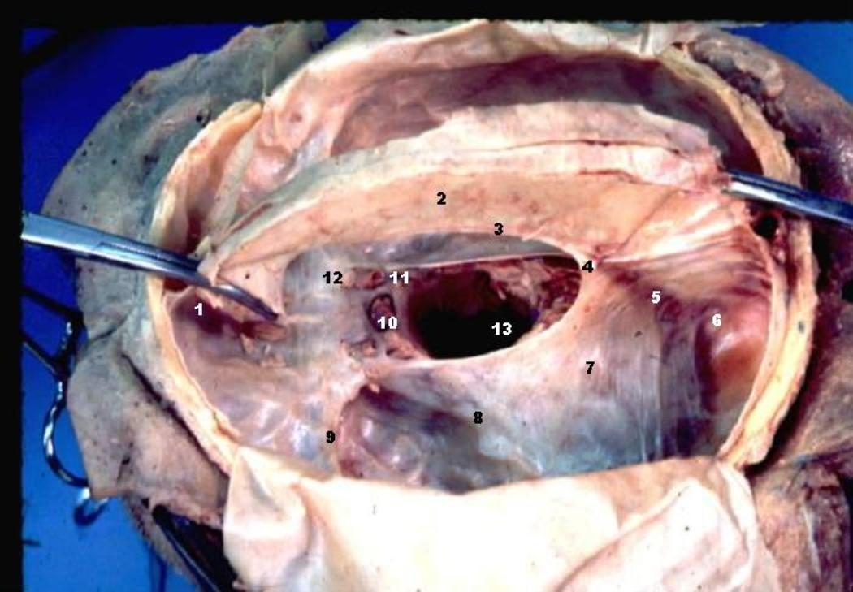

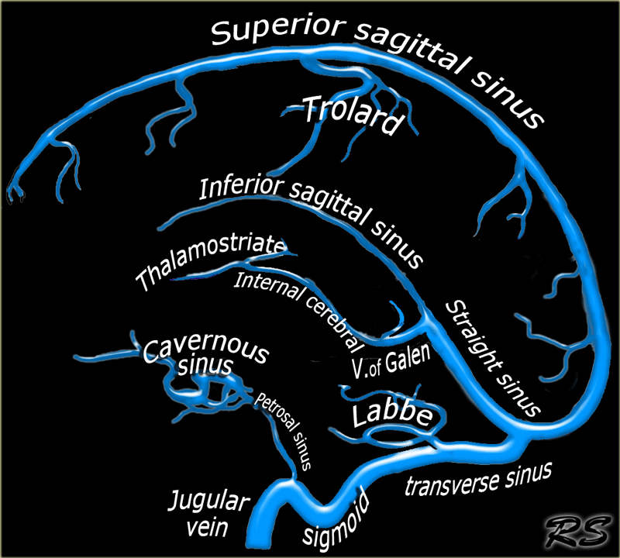

1. A patient presents with a pituitary tumor. What visual filed defects would the patient exhibit? How would the pituitary tumor be removed?
   1. Visual Defect = Bitemporal Hemianopia
   2. Pituitary removal - To get to pituitary gland - through the nose and into the sphenoidal sinus and then you break it and you get to the sella turcica
2. Be able to identify the muscles of the larynx. What are their functions? Which affect the vocal cords? What are their innervation?
   * 1. **Muscles:**
        1. **Cricothyroid** - stretches and **tenses** the Vocal ligament/vocal fold → **nerve** = External Laryngeal Branch.  Nerve (from Cranial Nerve X)
        2. **Thyroarytenoid** - **Relax** the vocal ligament
        3. **Posterior-Ciricoarytenoid**🡪**Ab**ducts vocal folds   
           **Lateral-Ciricoartyenoid**🡪**Add**ucts the vocal folds
        4. **Transverse & Oblique Arytenoids** - Addcuts the Arytenoid cartilages
        5. **Vocalis -** Relaxes the posterior Vocal Ligament while increasing tension in the anterior part
     2. \***Nerve Supply** 🡪Inferior Laryngeal Nerve- Vagus branch (Terminal part of the recurrent laryngeal Nerve from CN X.
     3. **Sensory supply**
        1. Mucosa above vocal fold by internal laryngeal nerve which will pierces thyrohyoid membrane 🡪 go to the Piriform recess of the Pharynx
        2. Mucosa below vocal fold by recurrent laryngeal nerve
           1. Vagus splits into superior and inferior laryngeal nerve 🡪 The Internal and externa laryngeal are br. Of superior laryngeal Nerve
           2. 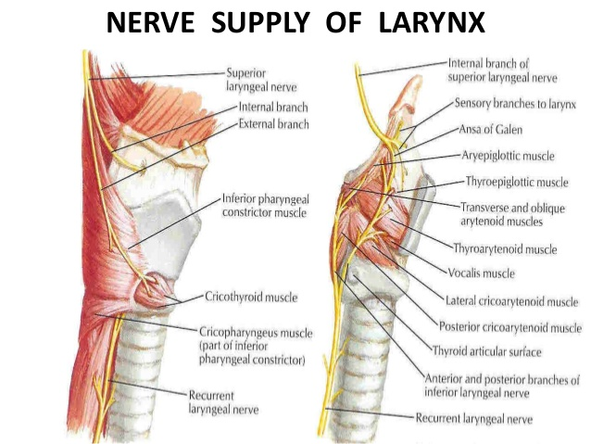
3. Where is the piriform recess located? What is its clinical importance? What nerve and blood vessel is it associated with? Be able to ID the piriform recess in an MRI/picture.
   1. **Laryngopharynx** - posterior to the larynx (lateral wall has the Piriform Fossa which can have swallowed bodies get stuck in it). (sensory = Vagus)
   2. When food passes through the laryngopharynx during swallowing, some of it enters the piriform recess and pierce the mucous membrane and **injure the internal laryngeal nerve**, lying in a groove adjacent to the recess.  Injury to the internal laryngeal nerve may result in anesthesia of the laryngeal mucous membrane as far inferiorly as the vocal folds. The **internal laryngeal nerve will come with the superior laryngeal artery**
   3. 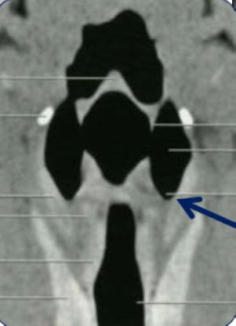 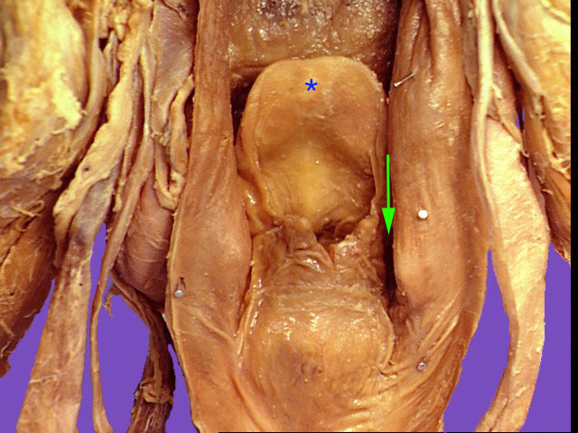
4. Be able to identify the blood supply of the thyroid in an arteriogram/diagram/image. Be able to identify variations of the blood supply.
   1. Blood Supply of the Thyroid Gland – Superior thyroid artery, branch of the external carotid artery, Inferior thyroid artery branch of the thyrocervical trunk. The Ima Artery – from the bacriocephalic trunk, arch of Aorta or right common carotid, subclavian, or internal thoracic, supplies anterior trachea and isthamus

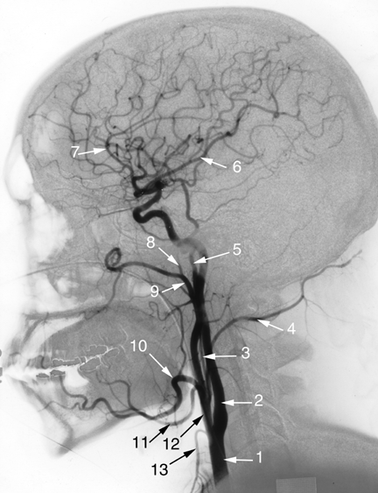

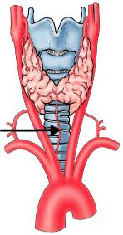

* 1. Common carotid, 2. Internal carotid, 3. Ascending pharyngeal, 4. occipital, 5. Superficial temporal, 6.middle cerebral, 7. Anterior cerebral 8&9 . maxillary 10. Facial, 11. Lingual, 12. External carotid, 13. Superior thyroid

1. What is the danger area of the face? What is its clinical significance?
   1. The danger triangle located in the upper lip and nose area
   2. Clinical – Infections can pass via **Direct: Facial –**superior ophthalmic vein – cavernous sinus **OR Indirect: Facial – Deep facial – Pterygoid plexus- emissary veins – cavernous sinus**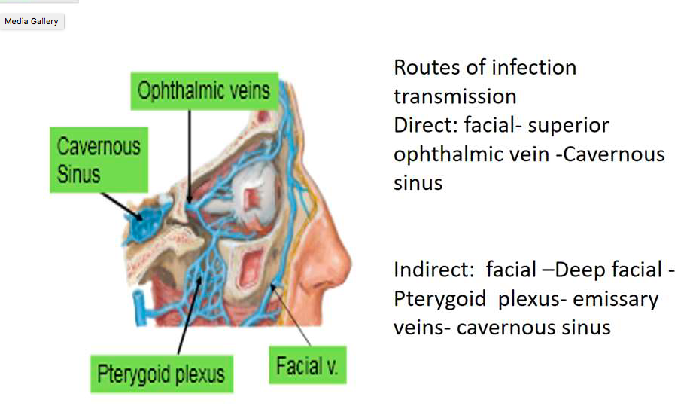
2. What nerve passes through parotid gland? Where does the parotid duct open into?
   1. Parotid gland has the Facial Nerve pass through it
   2. The Parotid duct opens into the vestibule of the mouth opposite the crown of the 2nd maxillary tooth.
3. What is torticollis? Which nerve is associated with torticollis? Which muscle is associated with torticollis? What are clinical symptoms of torticollis?
   1. Torticollis is the drooping of the shoulder to one side.
   2. Nerve: The Spinal Acessory nerve
   3. Muscles associated with Torticollis Sternocleidomastoid
   4. Clinical Symptoms of torticollis = Drooping head to one side  
      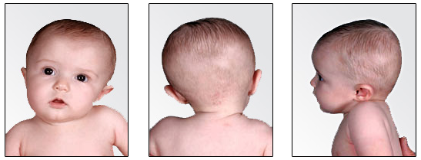
4. Be able to identify the foramina in the base of the skull and know which structures are associated with each of them.
   1. **Superior Orbital Fissure –** Transmits the CN III,IV,VI (branches of V1 – Nasocillary, lacrimal and frontal), Superior and inferior Ophthalmic veins
   2. **Inferior Orbital Fissure –** Communicate with the Pterygopalatine fossa and the Infratemporal Fossa, Transmits: Branches of the maxillary Nerve, & branches of the maxillary vessels into the orbit. 🡪 ex: infraorbital nerve(and artery) ( terminal br. Of Maxillary nerve) comes from the pterygoid fossa to the orbital via the inferior orbital fossa 🡪 floor of the orbit to the front of the face via infraorbital groove.
   3. **Supraorbital Notch or Foramina –** transmits the Supraorbital vessels and nerve (the supraorbital nerve is off of V1 but the supraorbital vessels are off of the ophthalmic artery.
   4. **Infraorbital Groove or Foramen –** Consist of the nasolacrimal duct that opens into the inferior meatus of the nose
   5. **Optic Canal –** Transmits the Optic Nerve and the Ophthalmic Artery
   6. **Forman Spinosum –** Middle meningeal artery
   7. **Foramen Ovale -** Mandibular Nerve (V3
   8. **Foramen Rotundum –** maxillary division of Trigeminal (V2
   9. **Jugular foramen -** Vagus Nerve, Glossopharyngeal and Spinal Accessory
   10. **Carotid canal –** internal carotid artery
   11. **Stylomastoid foramen** – exits the facial nerve   
       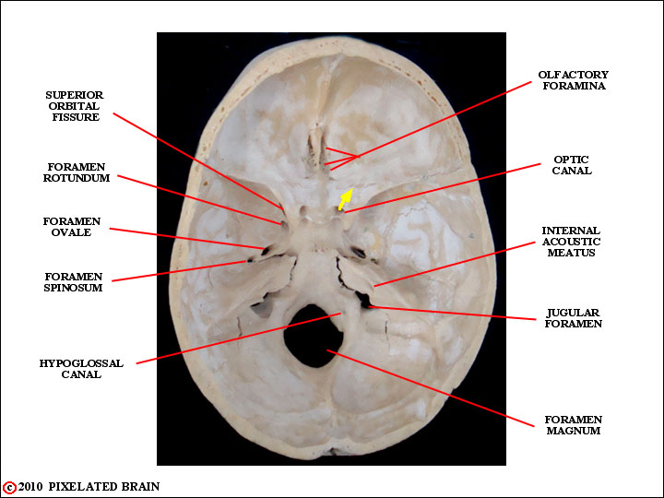
5. What nerves are associated with the light reflex? Which is the motor branch? Which is the sensory branch? What are the clinical symptoms if either of the nerves are damaged?
   1. The Optic Nerve (sensory)and the Oculomotor nerve (motor)
   2. Clinical Symptoms Damage Optic Nerve 🡪 If the Optic nerve is damaged on the right side and you reflect a light on the left side, there will be constriction of both eyes, provided oculomotor on both sides are normal (efferent) but if the light is shined on the right side there will be no constriction if the oculomotor is damaged.
   3. If one oculomotor nerve is damaged then that one eye will NOT constrict when light is shined upon it
6. What are the derivatives of pharyngeal pouches?
   1. Pouch 1 = Middle Ear  
      Pouch 2 = tonsils

Pouch 3 = Thymus, and inferior part of the parathyroid gland

Pouch 4 = Superior part of Parathyroid gland

1. What are the derivatives of neural crest cells?
   1. **Gives rise to PNS and ANS**
      1. **Spinal ganglia (DRG);** pseudounipolar neurons
      2. **Schwann cells;** myelinating single axon
      3. Leptomeninges **(pia and arachnoid matter)**
      4. CN sensory ganglia (CN V, VII, VIII, IX, X)
      5. Autonomic ganglia
      6. **Chromaffin cells** (medulla of adrenal glands, carotid body)
      7. **Otic vesicle**
      8. Connective tissue in arteries, glands, heart (interventricular septum)
      9. Facial and ventral skull bones
   2. ** failure of neural crest cells to develop/migrate can affect one or more of the derivatives
2. Be able to differentiate between all types of cleft lip and cleft palate and know which structures failed to fuse in each case.
   1. Oblique Facial Cleft - Lateral Nasal Prominence not fusing with the maxillary Part.
   2. Cleft Lip due to the Medial Nasal Prominence not fusing with the maxillary