 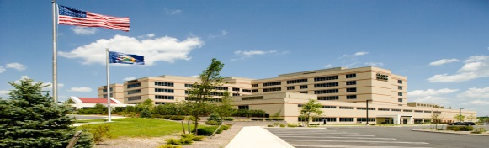 

**Diabetic Emergencies**

**Presented by: Dr. Dulaya Santikul**

**Emergency Medicine Attending Physician, ORMC**

**&**

**Dr. Matthew Moore, Emergency Dept. Resident**

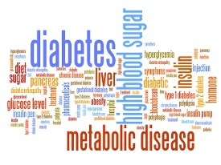 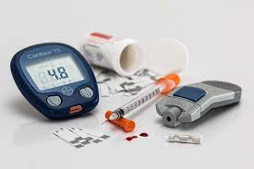

**When: Tuesday May 8th 7:30 PM- 9:00 PM**

**Where: ORMC Conference Center Rooms 1-3**

**Food will be Available**

Questions: John Nowinski EMT-P

[jnowinski@ormc.org](mailto:jnowinski@ormc.org)

(845) 741-8449