 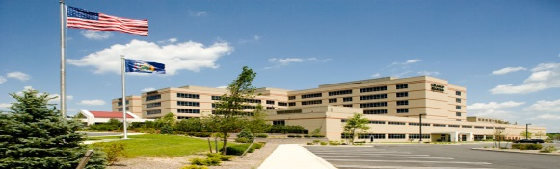 

**BURNS** 

**Presented by:** Emergency Medicine Attending Physician Dr. George- Varghese &

ED Resident Dr. Avindra Ramnarain

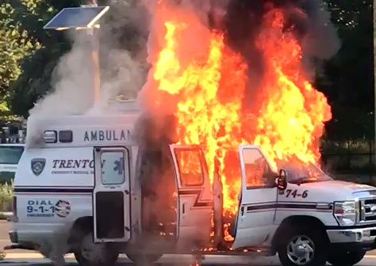

**When: Tuesday April 10th 7:30 PM- 9:00 PM**

**Where: ORMC Conference Center Rooms 1-3**

**Food will be Available**

Questions: John Nowinski EMT-P [jnowinski@ormc.org](mailto:jnowinski@ormc.org)

(845) 741-8449