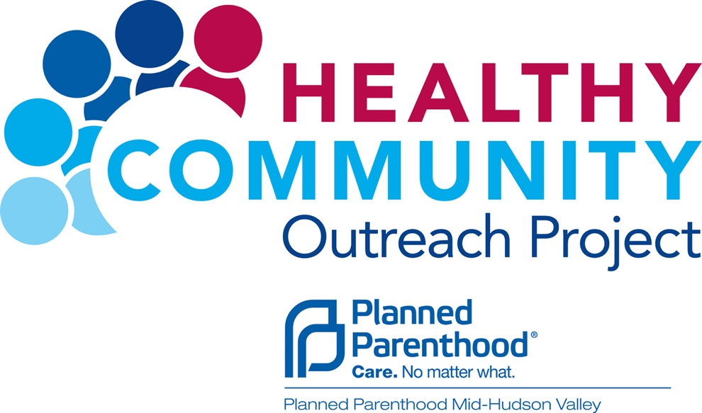

**PRESENTS**

**Intersectionality and Relationality:**

**Examining Empowering Approaches in Community Wellness and Sustainability and Fostering Optimum Education & Shadowing Asthma Workshop**

This workshop will explore the intersectionality and relational connection in addressing emerging challenges in wellness, mental health, nutrition, and conditions affecting minority communities, with a specific focus on Asthma. The work is designed to provide community and faith-based organizations with best practices that examine related issues that determine optimum health in diverse communities.

**Workshop Date:** Friday, March 2, 2018

**Time:** 10am – 12noon

**Venue:** Calvary Presbyterian Church,   
Rev. J. Edward Lewis   
120 South Street, Newburgh, NY 12550

**Workshop Led By:** Lydia N. Collins MLIS, Consumer Health Coordinator, National Network of Libraries of Medicine, Middle Atlantic Region (NNLM MAR)

**Please RSVP By:** February 27, 2018 – Gloria Miller 845-527-0157

Gloria.miller@ppmhv.org

A Product of: The *Council of Muballighuns of the Americas and the Caribbean* (CMAC): The Center for Faith & Cultural Wellness (CFCW) project.