 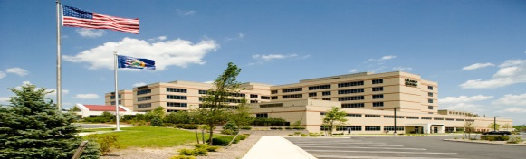 

**Sepsis**

**What is it, what do you do?**

**Presented by: Dr. Trevor McGinley**

**Emergency Medicine Attending Physician, ORMC**

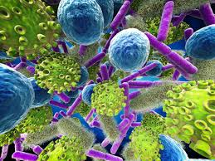

**When: Tuesday March13th 7:30 PM- 9:00 PM**

**Where: ORMC Conference Center Rooms 1-3**

**Food will be Available**

Questions: John Nowinski EMT-P

[jnowinski@ormc.org](mailto:jnowinski@ormc.org)

(845) 741-8449