Instructions for Registering for TCAlert

Go to the TouroOne portal at touroone.touro.edu and log in with your username and password.

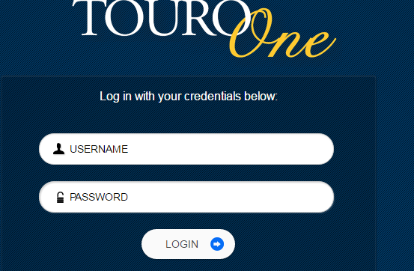

Click on the Employee or Student tab, depending on which category you fall under, and under My Personal Information for employees, and My Records for students, select View/Update Address and Phone.

EMPLOYEE SCREEN

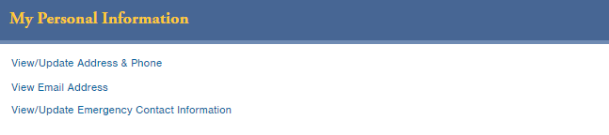

STUDENT SCREEN

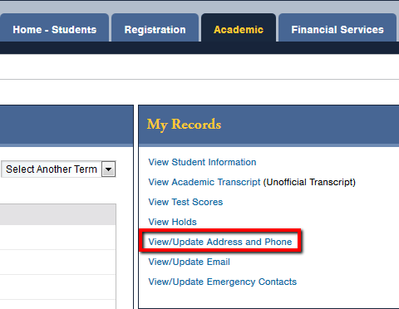

Your current information will appear on the screen. If your information is correct on the screen and you do not wish to change anything, simply hit Submit at the bottom of the screen and you do not need to go further. If your information is incorrect, blank or has information you wish to remove, you must enter the information for the changes to take effect. Click on the ‘Update Address and Phone’ section.

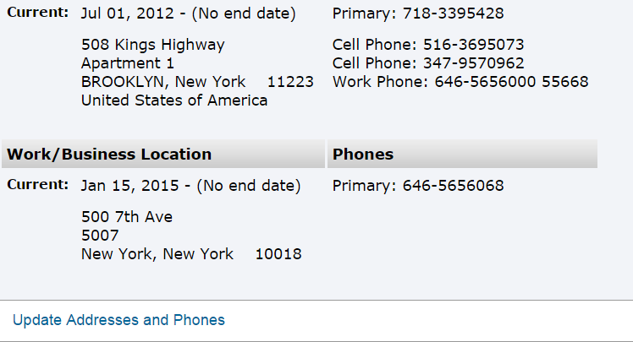

There will be several fields in blue lettering which you must select to make the changes.

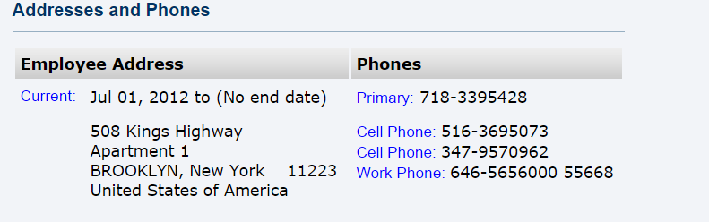

Current: Click and enter your home address. Enter a ‘Valid from Date’ of 01/15/2015; leave the ‘Until Date’ blank (do not fill in a date for this field).

Primary: Use this area to enter your landline number ONLY! If you do not have a landline number, or as a student, you do not want your parents' number to be contacted, ignore this area. DO NOT enter your cell phone number in this field or your information will not be picked up by the system.

Cell Phone: Enter the cell phone number(s) on which you would like to be contacted. You can enter up to four cell phone numbers, but we suggest no more than two.

Work Phone: Enter the number of your office phone with the main number of your building and add your extension in the extension field. This field is not applicable to Students.

After you have made all entries, go to the bottom of the page and click Submit. When the screen returns to the first page, DO NOT click Submit again or you will receive an error message.

If you receive an error message, please contact the Touro Help Desk at nonstop@touro.edu

