**VOLUNTEERS NEEDED**

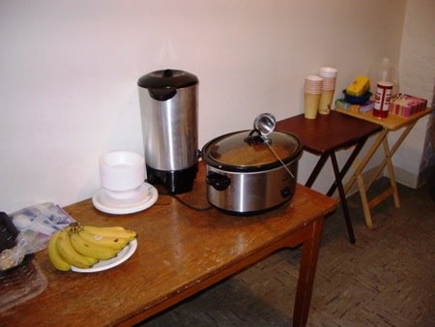

***Greater Middletown Interfaith Council’s Community Warming Station***

*A safe, overnight space for homeless men and women.*

Beginning Sunday evening November 19th and continuing each night (9 PM to 7 AM) during the cold months the Warming Station in Middletown will host and extend its hours for community needs to provide a warm and safe environment for homeless adults (up to 30) living on the streets in Middletown.

Men and Women are encouraged to volunteer overnight to supervise Middletown homeless men and women who have been screened for suitability.

St. Paul’s United Methodist Church   
 58 West Main Street  
Middletown, NY 10940 **(Use Mulberry St. Entrance)**

**Volunteers are also needed** to prepare and bring a hot dinner.  If you are interested in participating in this way, please reach Peg at[peglazzari@yahoo.com](mailto:peglazzari@yahoo.com)**. Or go to takethemameal.com Type in The Warming Station. Password is *meal.***

**To make any type of donation** (socks, hats, scarves, gloves.) please call Marilyn at (845) 342-2657 or email her at [midduce@hvc.rr.com](mailto:midduce@hvc.rr.com).