Touro College of Osteopathic Medicine

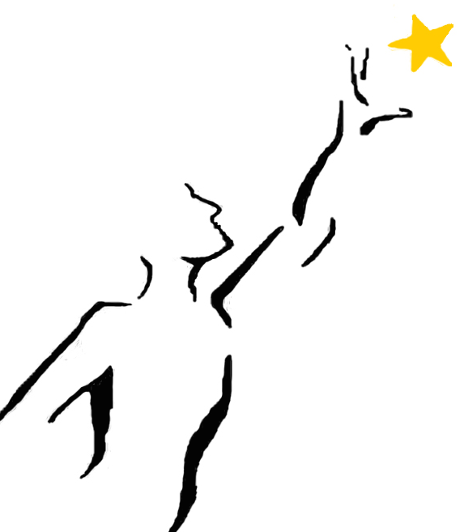

Middletown

REACH Program

Handout #4

Previewing a Lecture and

Connecting New Material

with Previously Learned Material

**Preparing to view recorded or live lectures**

Previewing - ‘Get Ahead and Stay Ahead’

It is important to find time to do a little pre-reading before viewing each lecture. This preview will give you early insight into the most important components of the lecture, and therefore, will save you time as you more quickly identify the key details of the lesson. “Pre-reading” will enable you to listen actively in the lecture, stay focused, and get the most from that time. You are more likely to understand and retain the lecture material as well.

Here are a few simple steps you could follow:

1. Allocate some time for each of the videos that you have to view, anywhere from 10 to 30 min each.

2. Look briefly at the objectives for that lecture (found either on the lecture slide set our course documentation book).

3. Use the slide set posted to Blackboard and/or assigned text book readings to pre-read. Do not worry too much about mastery of the material. At this point you are not trying to master the material. You are simply trying to gain basic familiarity with the topic.

4. Skim through the slide set/chapter – look at headings, key words and diagrams. Are there any terms that you know from other contexts, such as previous lectures? Do you remember them? Can you define them precisely? Now is a good time to go back and review these. More on this below.

5. List all key terms as you skim, including both old and new terms. If you can’t define it, it counts as new. Does the word itself suggest its meaning? Then look up the definition and paraphrase it – what does it mean to you? This list, adjusted during and after the lecture, can later become the basis for a concept map, an outline, or a self-test tool.

8. Think about items that are related to each new term that you already have knowledge of (from this or another course, or your own prior knowledge). For example, you have a lecture tomorrow on “smooth muscle function”. Ask yourself how this might be different from skeletal muscle function that was covered previously. Recall the distinguishing characteristics of skeletal muscle.

9. Think of (and write down) some questions that you hope will be answered in the lecture. If you can do any of this, it will help you get more from the recorded lecture.

**Connecting new information to that which you have previously learned**

The richer the set of neural pathways we have to connect to information, the more likely we are to remember and use that information.Therefore, reviewing earlier concepts or underlying foundational knowledge before beginning a new area helps stimulate applicable prior knowledge. This also helps to see how new ideas tie into areas that you are already familiar with. Therefore, before you get underway with the new material, take time to draw comparisons between the new and old knowledge. Here are some ideas for how to work this into your studying:

* Use the KWL chart to connect new information to prior knowledge.

The traditional KWL Chart can be used with any content area to stimulate/organize/thinking about what you already **K**NOW about a topic (prior knowledge that is tied to the new content), what you **W**ANT TO KNOW about that topic (how does the prior knowledge extend into the new content area), and what you have **L**EARNED at the end of the process (tying it all together). See the attached example of a KWL chart.

* Brainstorming

Take a few minutes to brainstorm on everything that you have previously learned that is related to or connected to the new material. Review the list, and bring together items that are related to the same or similar concepts. Once this is complete, fill in the missing pieces. If you are struggling to piece things together into a complete picture, go back to your notes and review the target material. Finally, take the next step and clarify the connection between this previous material and the new material.

|  |  |  |
| --- | --- | --- |
| **What I KNOW** | **What I WANT to Know** | **What I LEARNED** |
|  |  |  |